CityLearn

Introduction
- open source Gymnasium environment for the implementation of Multi-Agent Reinforcement Learning (RL) for building energy coordination and demand response in cities
- Compare algorithm performance - CityLearn facilitates and standardizes the evaluation of RL agents for easy comparison
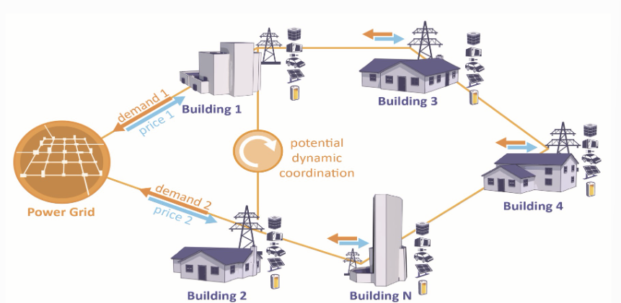
- Districts and cities have periods of high demand for electricity, which raise electricity prices and the overall cost of the power distribution networks.
- CityLearn allows the easy implementation of reinforcement learning agents in a single or multi-agent setting to reshape their aggregated curve of electrical demand by controlling:
  - active energy storage for load shifting
  - heat pump
  - electric heater power for load shedding.
- RBC, RL or MPC agent(s) control:
  - active storage devices by determining how much energy to store or release, and the cooling
  - heating device by determining their supply power at each control time step.

Observation
There are 52 observation values, grouped into 4 different categories: Calender, Weather, Distinct and Building.
The observation that are dependent on the actions taken by the agent are calucated during the simulation runtime.
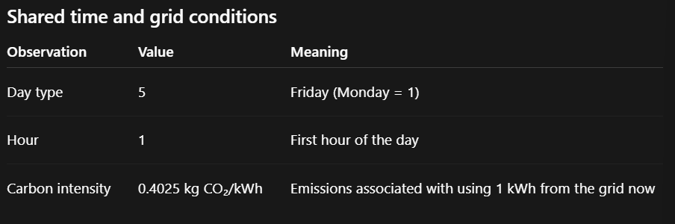
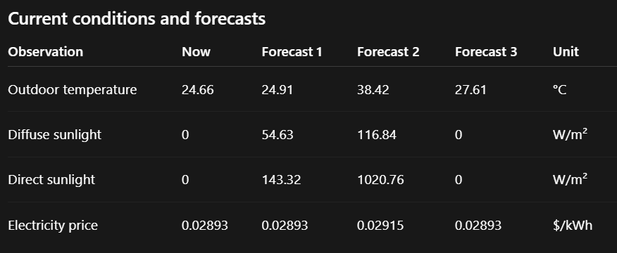
Note:
- Diffuse Sunlight reaches a surface indirectly from the sky
- Direct Sunlight comes straight from the sun
- The three forecast columns typically means 6, 12 and 24 hours ahead respectively
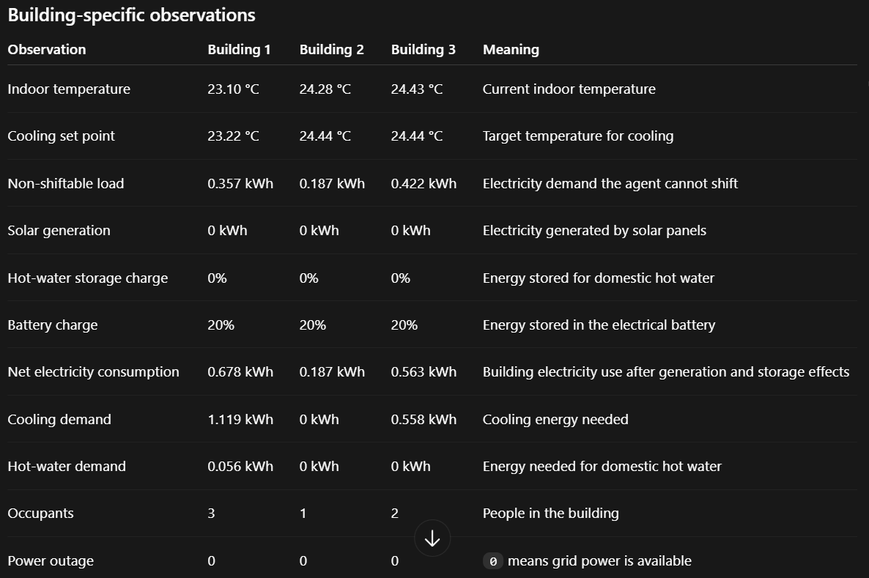

Action space
There are three continuous actions for each of the three building
Action | Range | Meaning
dhw_storage | [-1, 1] | Discharge or charge hot-water storage
electrical_storge | [-1,1] | Discharge or charge the battery
cooling_device | [0,1] | Fraction of cooling power made available

So the central agent has a 9-dimensional continuous action space.
Example:
actions = [[
0.2, 0.0, 0.6, # Building 1
-0.3, 0.5, 0.8, # Building 2
0.0, -0.4, 0.7, # Building 3
]]

Agent this means:

- For building 1 charges hot-water storage, leaves its battery idle, and makes 60% cooling power available
- For building 2 discharging hot-water storage, charges its battery, and makes 80% cooling power available
- For building 3, leaves hot-water storage idle, discharges its battery and makes 70% cooling power available
For building 1, charges hot-water storage by 0.2 means that requesing the hot-water tank store additional thermal energy equals to 20% of its total capacity during this time step. That is +20% of capacity. Then -1 means request the maximum permitted discharge, ie, to use as much hot water from the storage tank as possible to satisfy the current demand ( Use the tank as much as you can right now )
Interpretation of Hot-water storage and battery Storage charge and discharge:
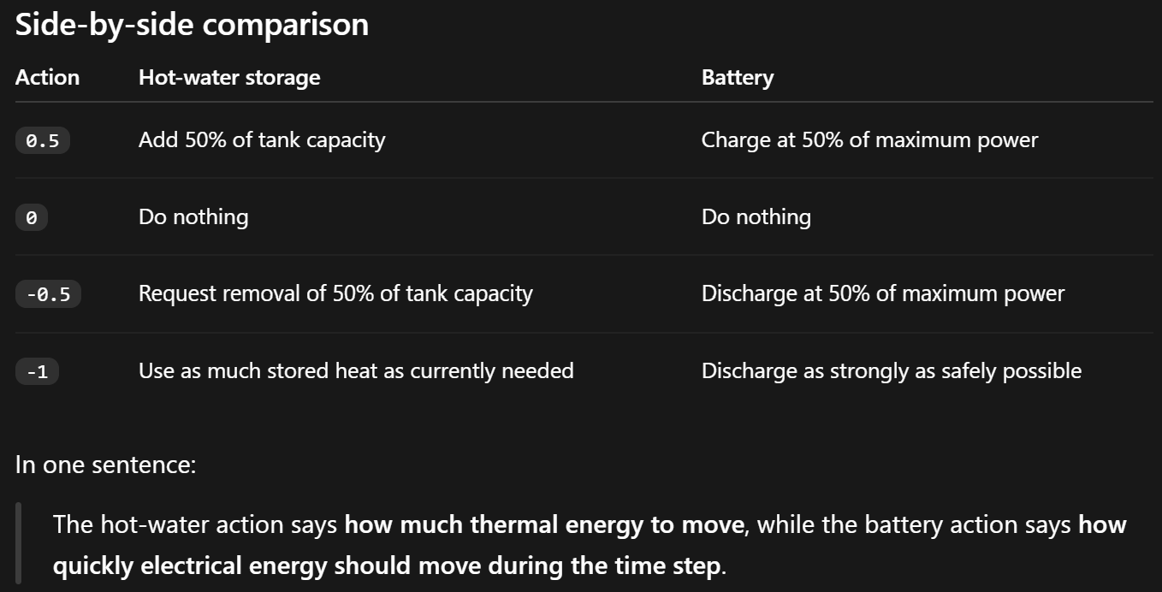
Agents
CityLearn package supports the following control architectures:
- Centralized
- Decentralized-independent
- Decentralized-coordinated
[Note]
- Centralized: Means 1 agent controls all storage, cooling and heating devices in the district
- Decentralized-independent: Means each building has its own unique agent abd building agents do not share information (Agents acts in isolation)
- Decentralized-coordinated: Information is shared among agent controlling each building
Summary:
Agents | Control Algo | Centralized | Independent | Coordinated
agents.rbc | RBC | Yes | Yes
agents.sac | RLC | Yes | Yes
agents.marlisa | RLC |  | Yes | Yes

[Note]
- SAC: Soft Actor Critic
  - Actor: Selects the actions
  - Critic: estimates whether those actions are beneficial
  - Entropy Term: encourages exploration instead of always selecting the same action too early
  - Replay Buffer: stores previous experiences for training

- MARLISA: Multi-Agent RL with Iterative Sequential Action Selection
  - Built on SAC, designed specifically for coordinating multiple building

Evaluation
agent.env.evaluate() . Examines the simulation history stored in the environment and calculates the KPIs
It evaluates the episode currently stored in agent.env()
The returned metrics includes:
- Carbon emissions
- Electricity cost
- Electricity consumption
- Peak demand
- Ramping
- Load factor
- Occupant discomfort
- Thermal resilience
- Unserved energy during outages
These metrics are cost functions or KPIs
Many legacy metrics returned by evaluate() are ratios:
Reported value = controlled result / built-in baseline result
The built-in baseline result is CityLearn’s estimate of what would have happened over the same simulation period without intelligent control. The built-in baseline is independent of whether the controller is SAC, MARLISA or RBC. It represents the same no-control reference scenario.
It will be identical when these settings match:
- Dataset and CityLearn version
- Buildings included
- Evaluation start and end time steps
- Weather, loads, prices and carbon intensity
- PV and power-outage settings
- Random seed
- Evaluation condition and comfort band
For a fair comparison, train the agents however you want, but evaluate all final controllers on the same fixed test period and environment configuration. Avoid comparing the final training episodes if CityLearn selected different episode periods for each algorithm.

Project Plan
Baseline Independent SAC MARLISA Fair Carbon Aware modification
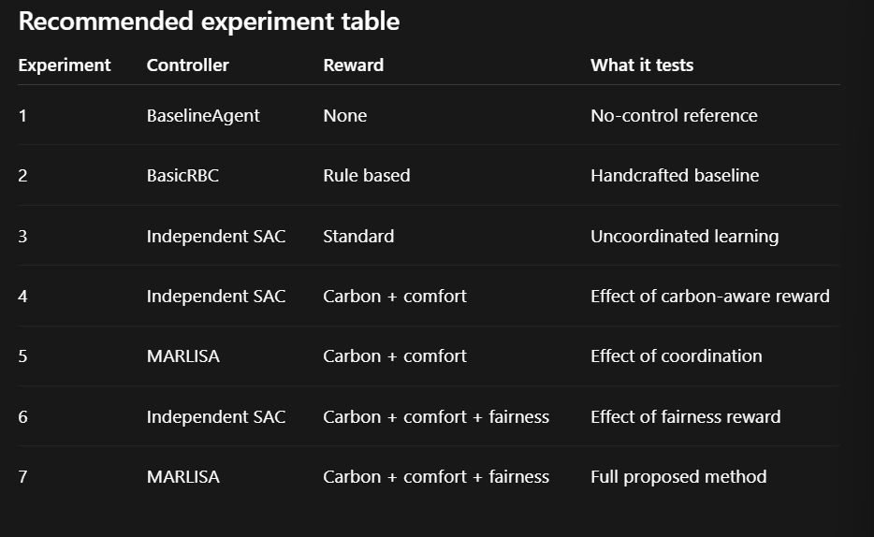

Important Research Papers:
Nweye et al., “CityLearn v2: Energy-flexible, resilient, occupant-centric, and carbon-aware management of grid-interactive communities.”
Vázquez-Canteli et al., “CityLearn: Standardizing Research in Multi-Agent Reinforcement Learning for Demand Response and Urban Energy Management.”

Haarnoja et al., “Soft Actor-Critic: Off-Policy Maximum Entropy Deep Reinforcement Learning with a Stochastic Actor.”

Vázquez-Canteli, Henze, and Nagy, “MARLISA: Multi-Agent Reinforcement Learning with Iterative Sequential Action Selection for Load Shaping of Grid-Interactive Connected Buildings.”

Kathirgamanathan et al., “A Centralised Soft Actor Critic Deep Reinforcement Learning Approach to District Demand Side Management through CityLearn.”

Nweye et al., “The CityLearn Challenge 2022: Overview, Results, and Lessons Learned.”

“Achieving Fairness in Multi-Agent MDP Using Reinforcement Learning.”

